 | Weekly Team Task Report | #9

Team: GeoLearn |  |  |  |  |  | Date: 3/24/2020
Project Title: Improving elementary education with custom online enironmental science lectures

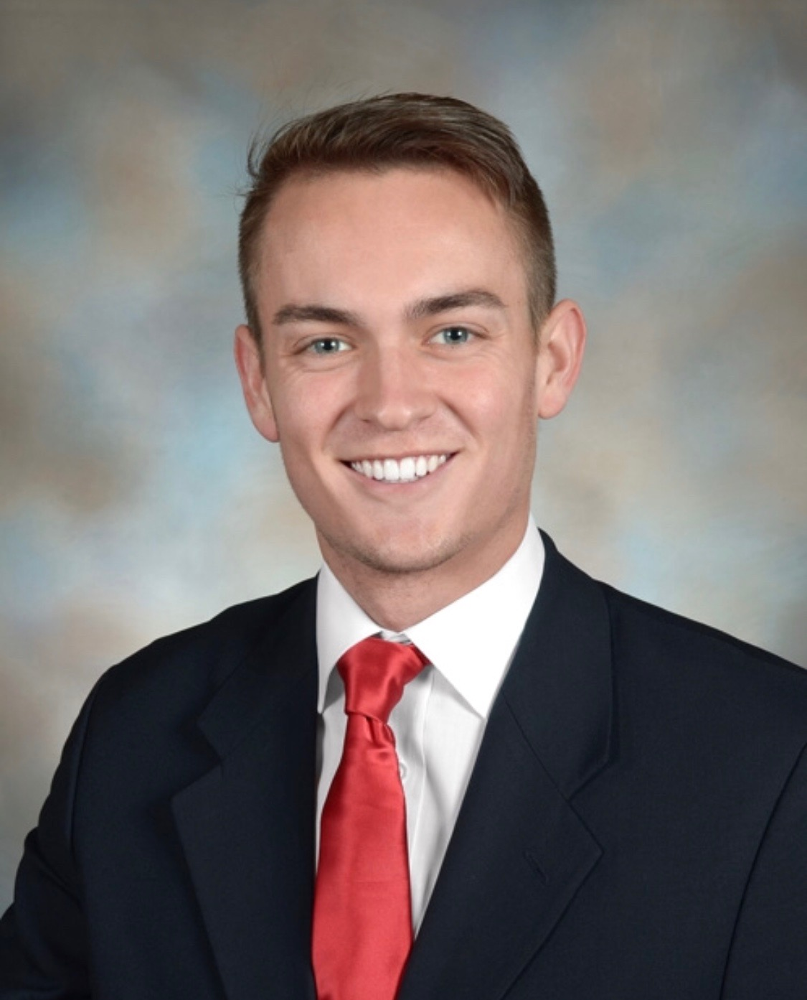 | Samuel Prassse  Present  On-time | 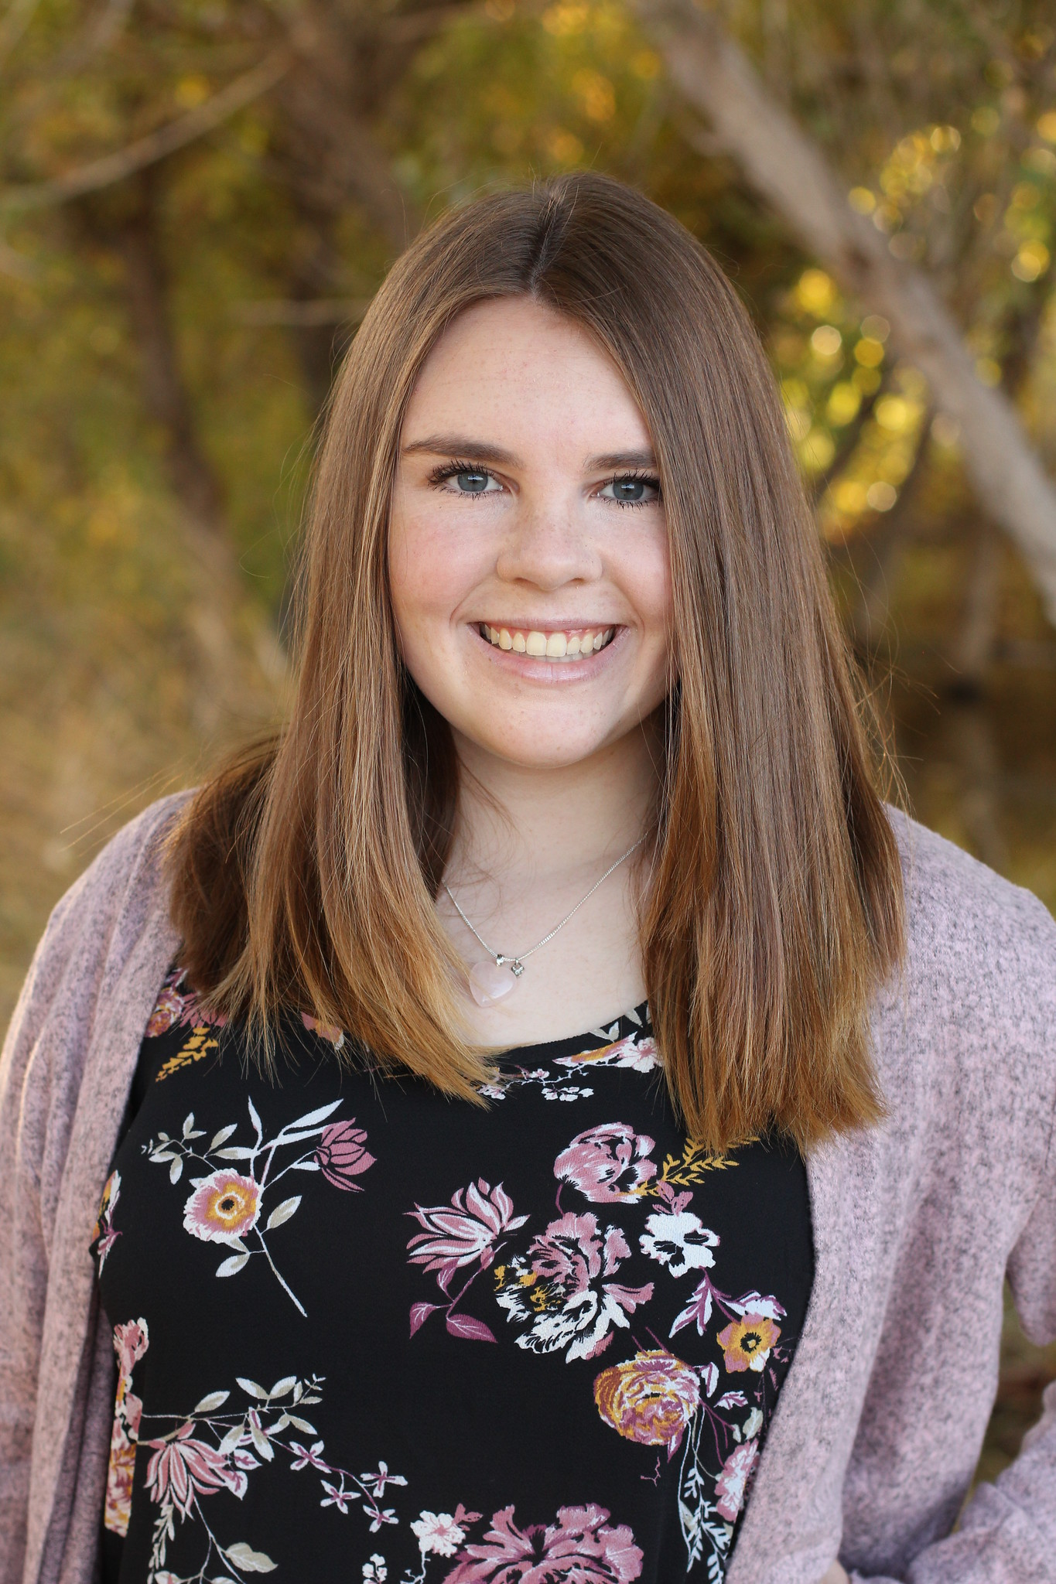 | Kaitlyn Grubb  Present  On-time | 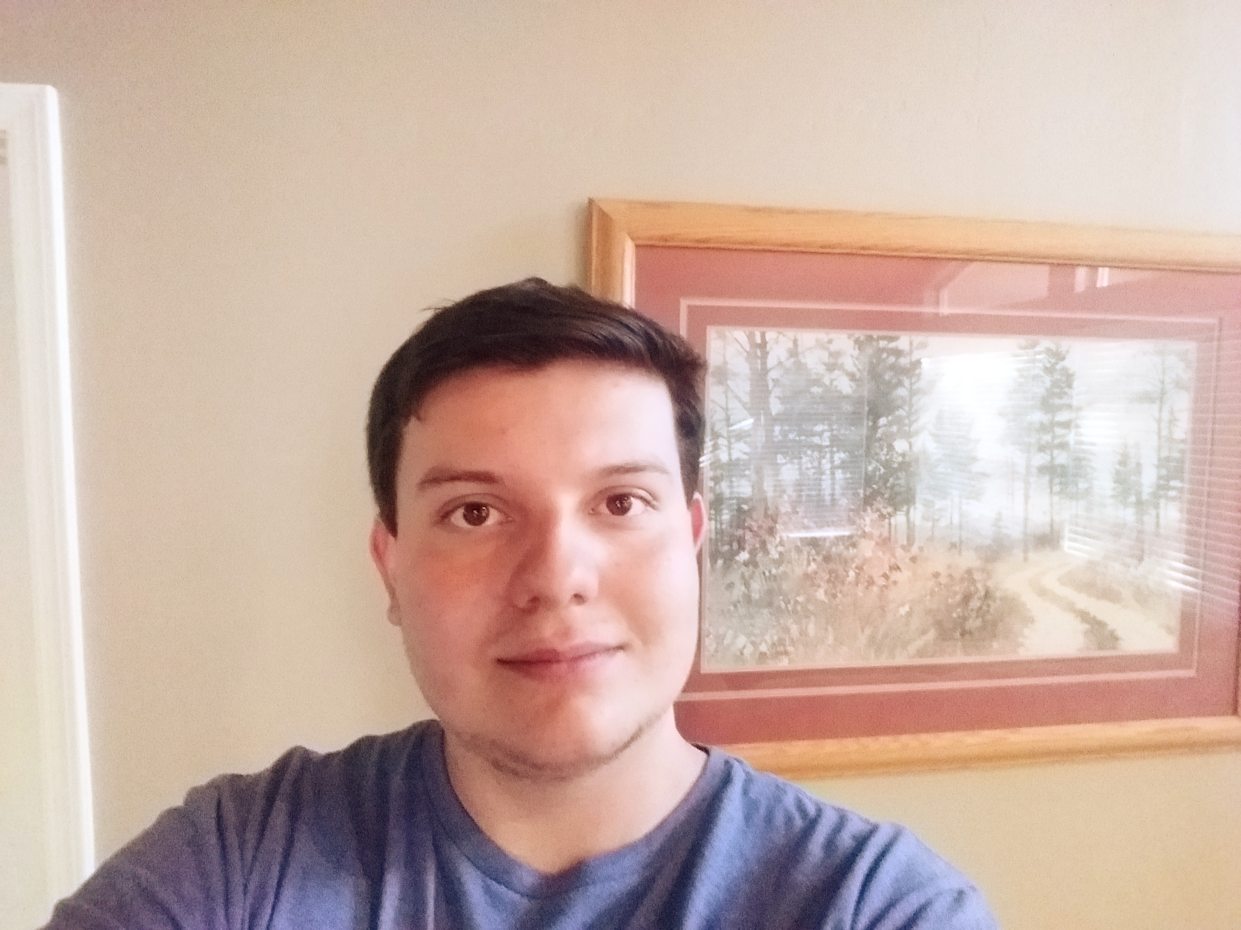 | Tyler Pehringer  Present  On-time |  | 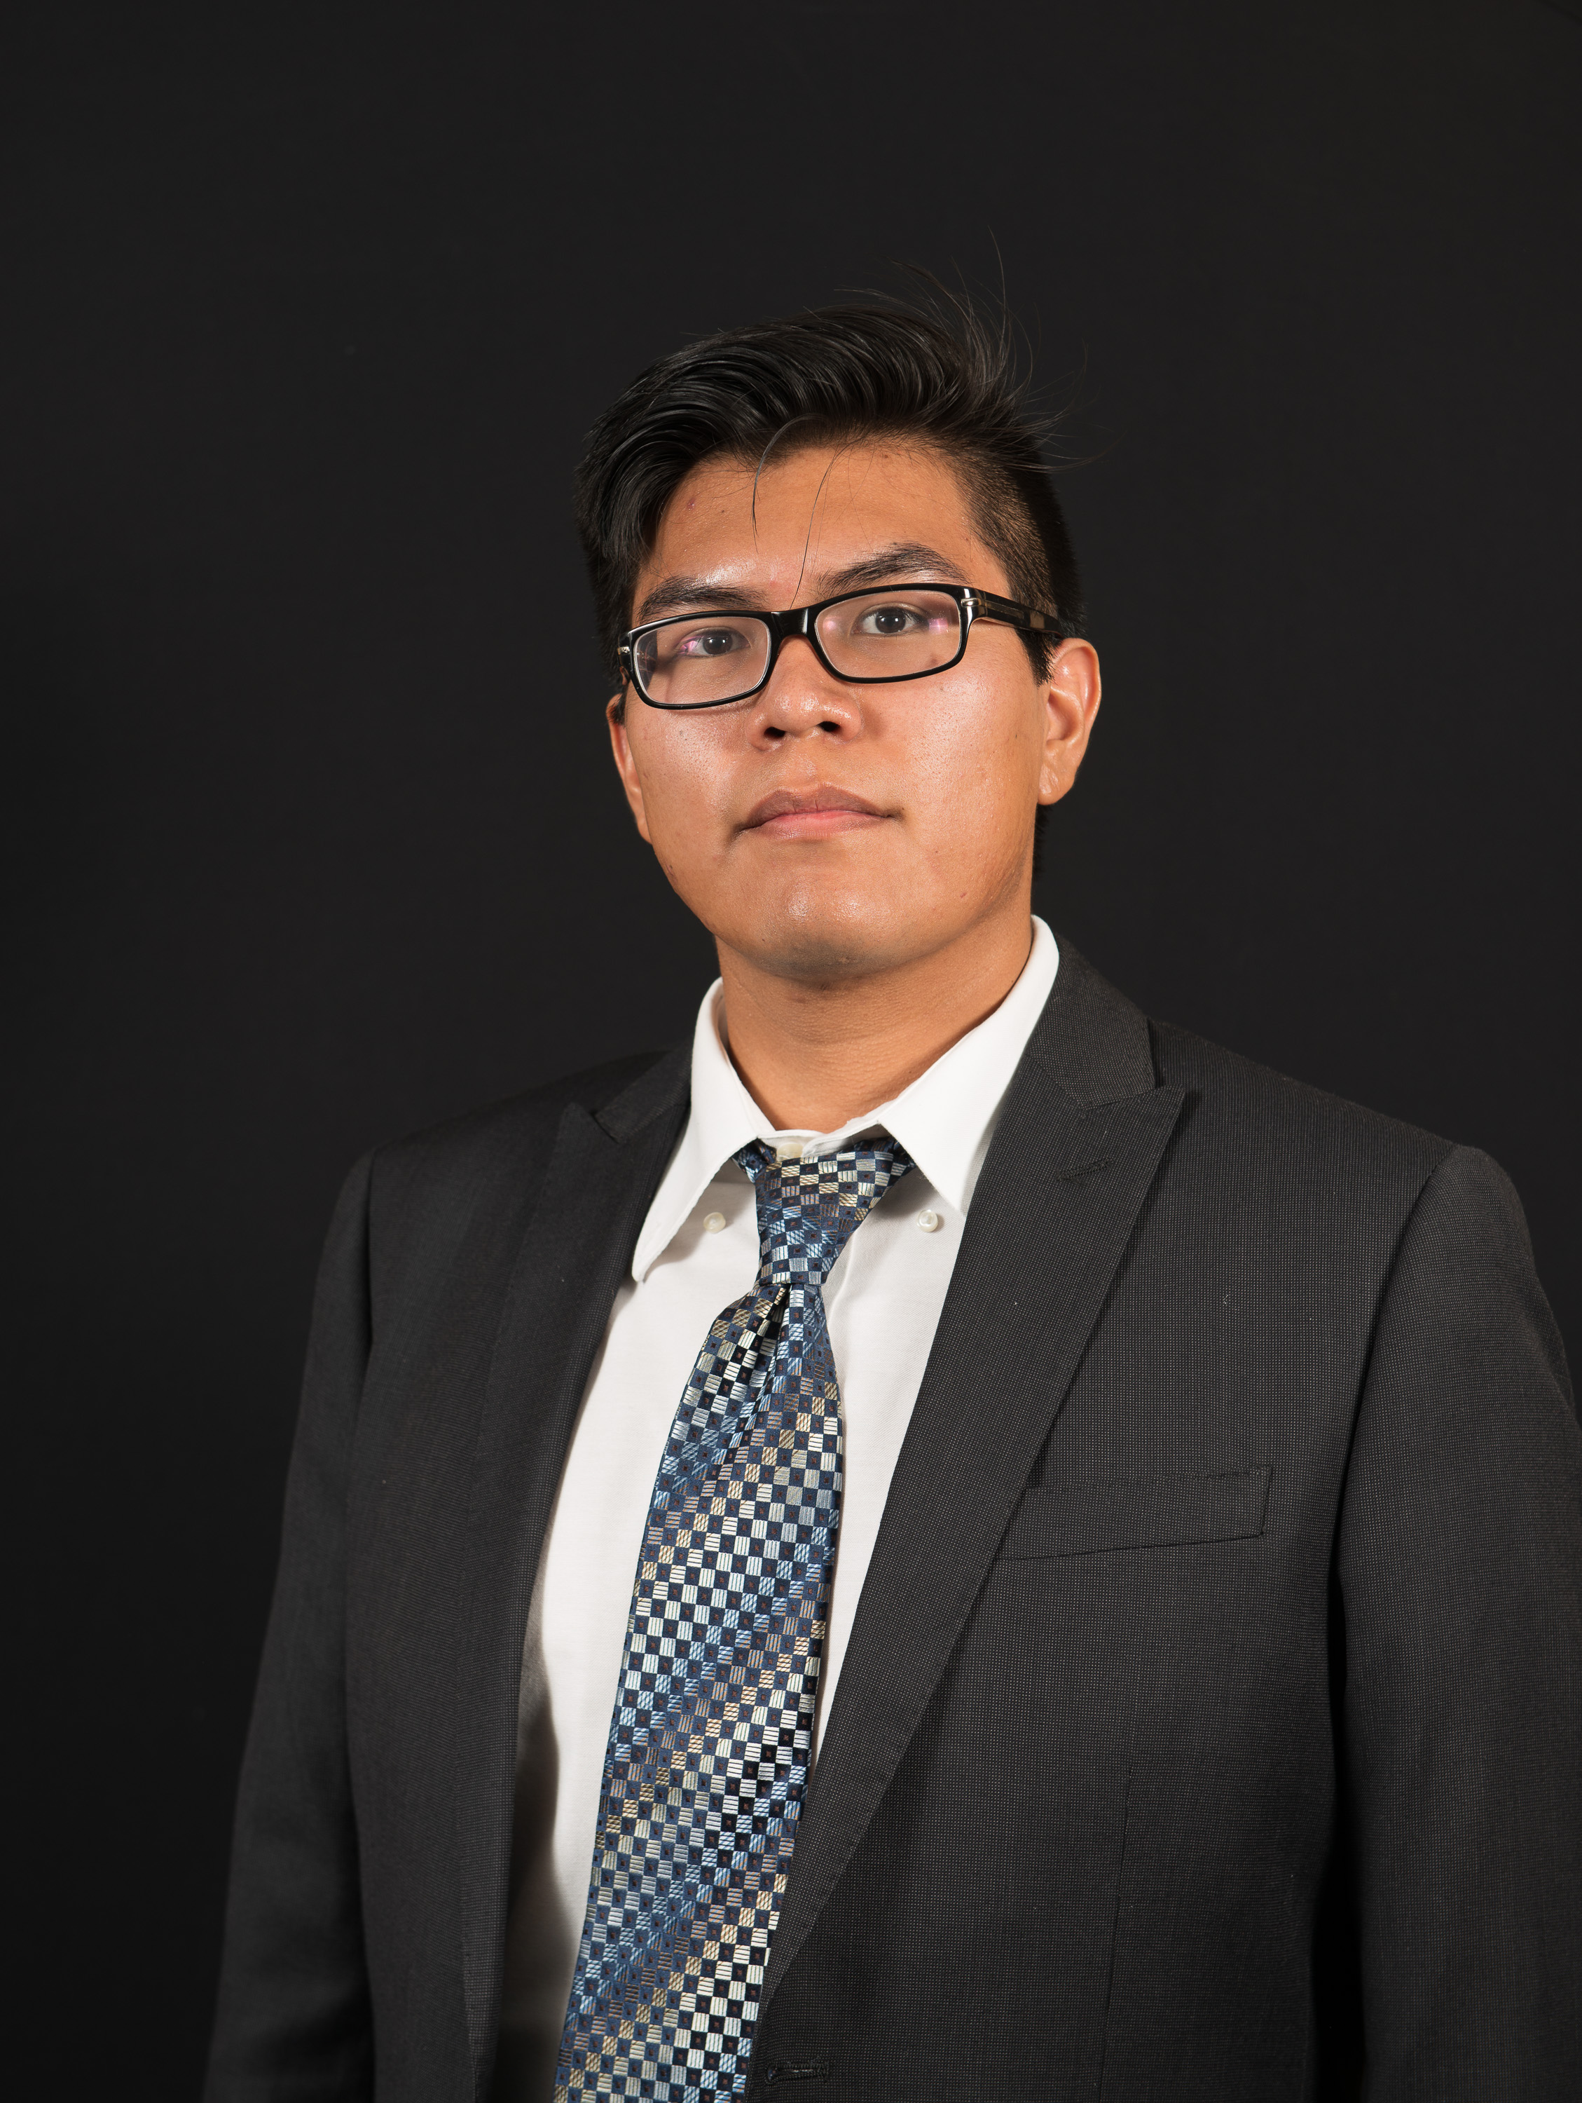 | Joshus Tenakhongva  Present  On-time

Recent Meetings:
- General Team Meeting

TASKS COMPLETED since last meeting:

Task Title: Continue website design | Task Initiation: 3/9 | Orig. Due Date: 3/16 | Status: In Progress
Who (%): Tyler (100%)
Description: Tyler will continue to develop the design of the website through meetings with Dr. Doughty and Roo.
Expected Outcome: A sleek website that conforms to the sponsor’s specifications.

Task Title: Peer Eval 2 | Task Initiation: 3/9 | Orig. Due Date: 3/13 | Status: In Progress
Who (%): Team (100%)
Description: Team will submit peer evals to Fabio by Friday the 13th.
Expected Outcome: Review the teammates relative to their performances over the past month.

This week’s Tasks: Work plan for coming week
Task Title: Software Testing Plan | Task Initiation: 3/9 | Orig. Due Date: 3/27 | Status: In Progress
Who (%): Team (100%)
Description: The team has been and will continue progress on the software testing plan for our web application. By completing this task, we are ensuring that our project’s implementation exhibits the necessary functional and non-functional characteristics.
Expected Outcome: A concise plan to torture test our product to ensure that it will perform to our team’s specifications.

Task Title: Continue website design | Task Initiation: 3/9 | Orig. Due Date: None | Status: In Progress
Who (%): Tyler (100%)
Description: Tyler will continue to develop the design of the website through meetings with Dr. Doughty and Roo.
Expected Outcome: A sleek website that conforms to the sponsor’s specifications.

Task Title: Database differences | Task Initiation: 3/23 | Orig. Due Date: 3/27 | Status: In Progress
Who (%): Joshus (100%)
Description: Joshus is looking into the differences that he finds between the Animaps database, and our database.
Expected Outcome: Determine why their data is so different than the ones we currently have.

Task Title: Documents for Slides | Task Initiation: 3/23 | Orig. Due Date: 3/27 | Status: In Progress
Who (%): Kaitlyn (100%)
Description: Kaitlyn will be working on the docuements for the slideshow presentattions.
Expected Outcome:

Task Title: Python Script | Task Initiation: 3/23 | Orig. Due Date: 3/27 | Status: In Progress
Who (%): Samuel (100%)
Description: Samuel will be working on a Python script that will grab the video from the google drive, convert it to a gif, and reupload it to the google drive.
Expected Outcome: A quick and optimized process for adding GIFs to our presentations.

Upcoming Tasks: Planning
Task Title: Design Review 3 | Who (%): Team (100%) | Rough Due Date: 4/3
Description: Prepare for the third design review. Not sure how it will be given now that University is completely online.

Other Problems / Other Issues:
- How collaboration will work now
- Need several team meetings a week on Discord to ensure comms are at their peak
- Set goals this week during meeting for project completeness

Github:

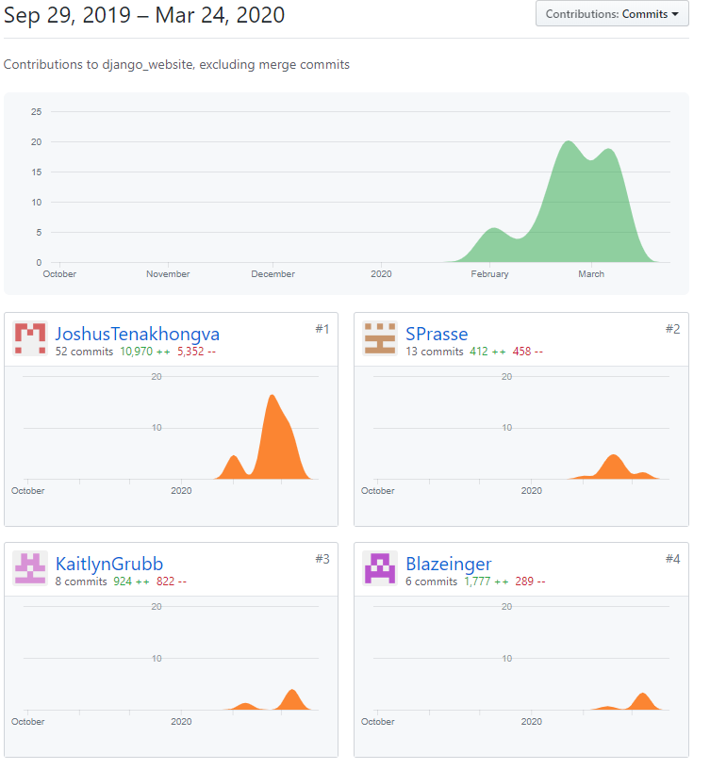

Schedule:

